

**North Western University**

***Department of Computer Science and Engineering***

**Sessional Final Report**

**Course Code:CSE-3304**

**Course Title:Computer Network Sessional**

Title: Introduction to computer network using NS2 based on the domain as Twitter

**Submitted To :**

**MD Shymon Islam**

Lecturer

Department of CSE

North Western University

**Submitted By :**

**Khandaker Istekharul Haque Jaba Baidya Nishat Yeasmin Arzu**

Id:20201125010 Id:20201132010 Id:20201149010

Department of CSE Department of CSE Department of CSE

North Western University North Western University North Western University

**Date of Submission: 22/12/2022**

***Table of Contents***

1.Overview of the project 3

2.Introduction to Zen Map 4

3.Four different source to domain 4

4.Design network topology **7.**

5.Prepare excel sheet for network diagram 8

6.Introduction to NS2 10

7.Source code of NS2 10

8.Output topology of NS2 11

9.Summarization of the designed network 13

10.Conclusion 14

11.Reference 14

Overview of the project

This project presents the theoretical and practical analysis of routing IP. Routing in computer network is an essential functionality, which influence both the network management as the quality of services in global networks.In this project we try to find a website detailed information about IP address, protocols and services running on the network. Firstly, we select a web site. The name of selected website is [Twitter t](http://www.wikipedia.org/)hen scan it by Zen map by four different networks. Then we create a topology. Secondly, we created an IP routing by excel sheet. Thirdly, we use NS2 for routing graphical interface. We created a figure on the basis of the excel sheet. By this project work we can find the networks in detail in order to identify potential security vulnerabilities and other problems.

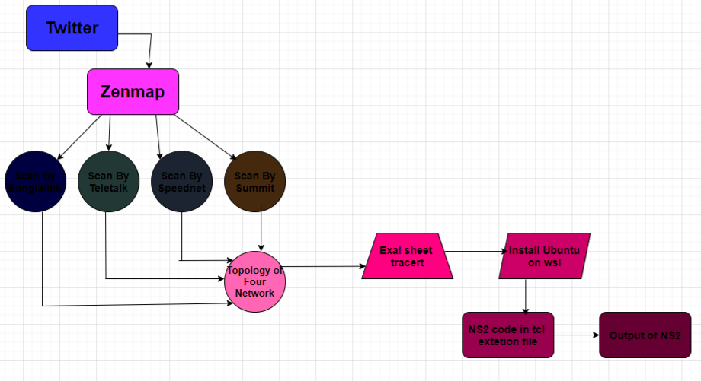

Fig 1: Bird’s eye view of the project

# 

# 1.Introduction to Zen Map

Zenmap is a graphical user interface for Nmap. It is a free and open-source software that helps you get up and running with Nmap. Zenmap lets you create a topology map of discovered networks.  It is a cross platform application available for Linux, Windows, and OS X.

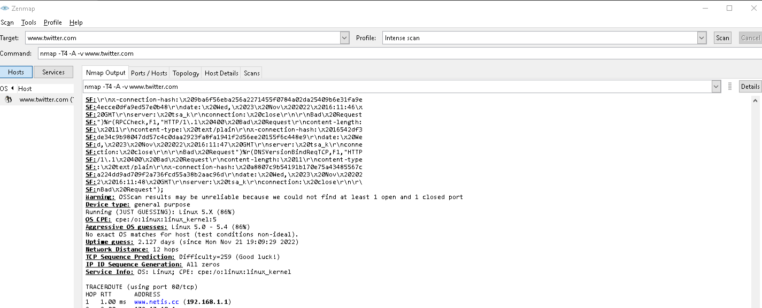

Fig 2: Zen Map interface

# 2.Four different source to domain

In this project we have scan Twitterby four different network and find the routing. We scan this website by two cellular network and two are WIFI network. Here we can see the four different network scan instance.

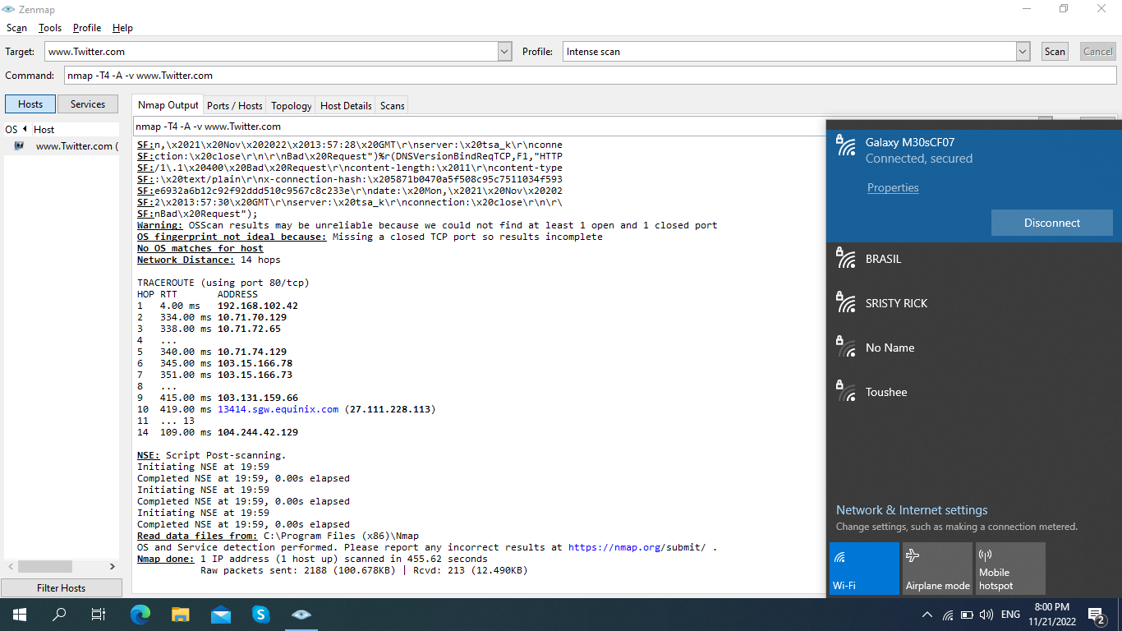

Fig 3: Banglalink network Zen map scan output

Here Fig 3 is the Banglalink cellular network output. In this scan output we can see that there are 9 different IP address from host to domain.

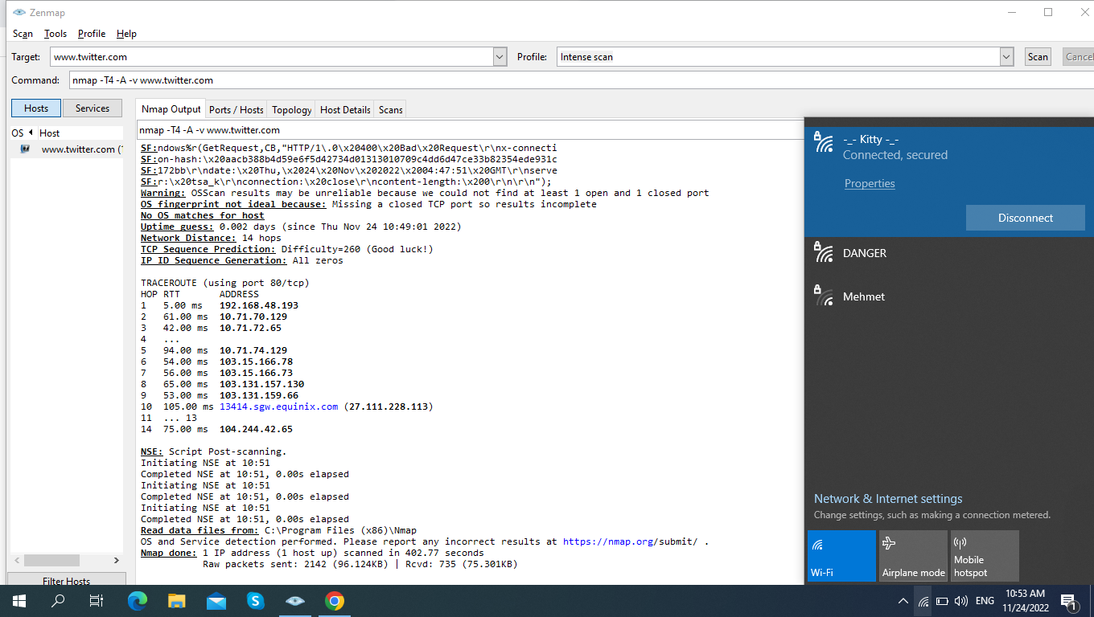

Fig 4: Teletalk network Zen map scan output

Here Fig 4 is the Teletalk cellular network output. In this scan output we can see that there are 10 different IP address from host to domain.

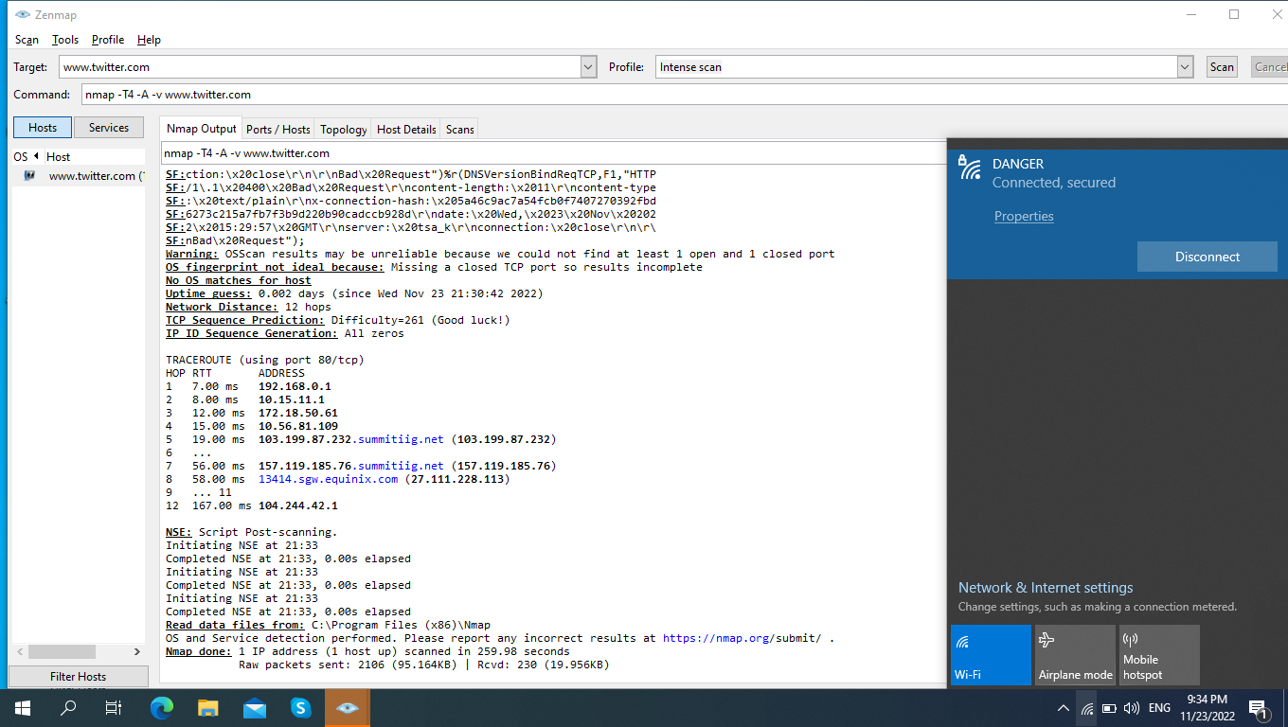

Fig 5: Speednet ISP Zen map scan output

Here Fig 5 is the Speednet Network ISP output. In this scan output we can see that there are 8 different IP address from host to domain.

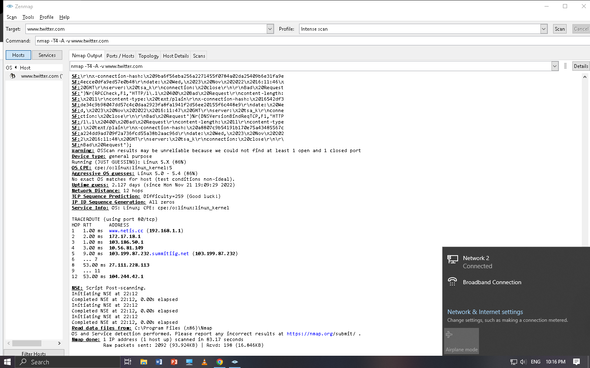

Fig 6: Summit ISP Zen map scan output

Here Fig 6 is the Summit Network ISP output. In this scan output we can see that there are 7 different IP address from host to domain.

**3.Design network topology**

Network topology is the arrangement of computers, network devices and other components of a network. It describes how various devices in a network are connected to one another and how they communicate. Network topology can be either physical or logical. Physical topology describes the physical layout of a network and the location of the various devices, while logical topology describes how data is transferred between the different nodes.

In our project our targets Ip is same but hosts Ip is different. After scanning by Zen map, we can draw a network topology.

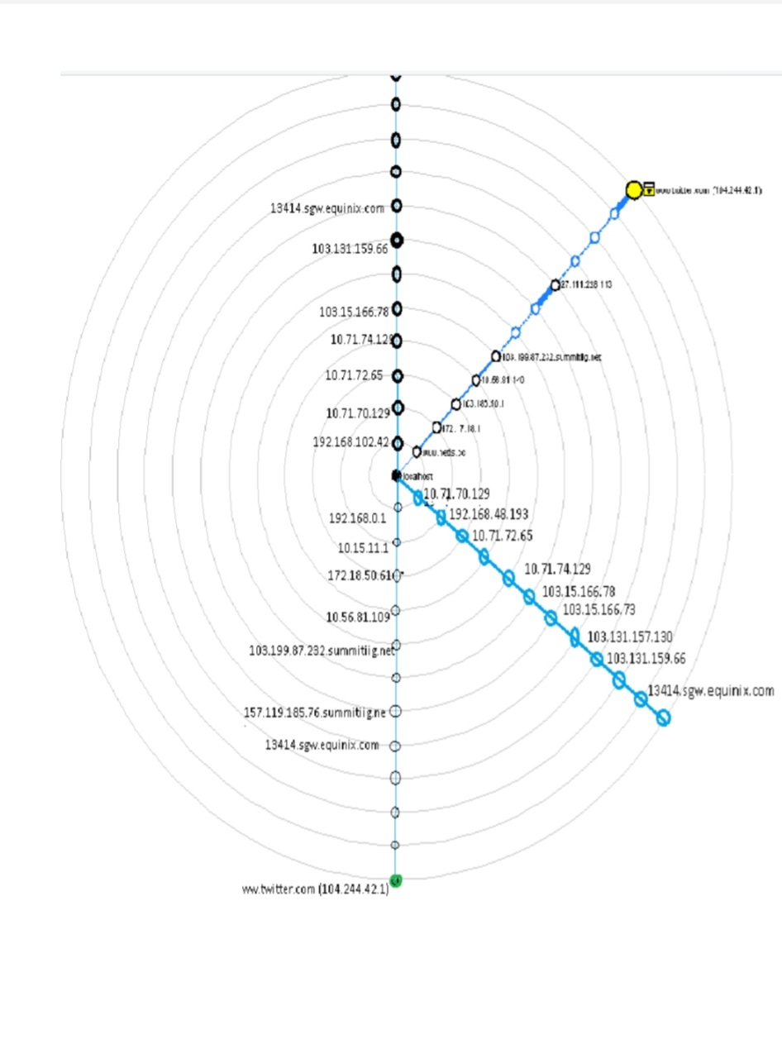

Fig 7: Network topology of Twitter

Fig 7 is the network topology of Twitter. Here we can see that host IP address are different but the target IP address are same.

# 4.Prepare excel sheet for network diagram

After Creating network topology by Zen map now we have to ready a excel sheet for simulation. First, we need to prepare four service table by serial by serial Ip address. Then we need to put it into a another excel sheet by serial by serial. Bellow there is a sample of excel sheet.

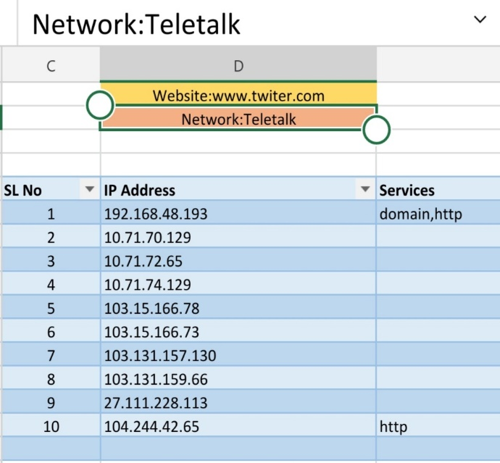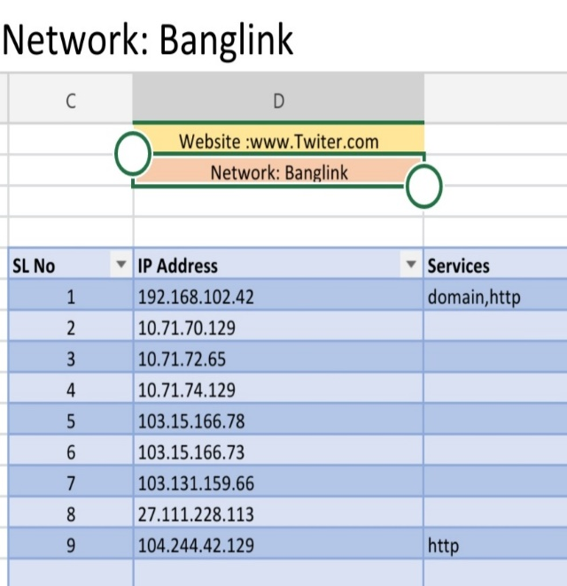

Fig 8: Service table of Banglalink Fig 9: Service table of Teletalk

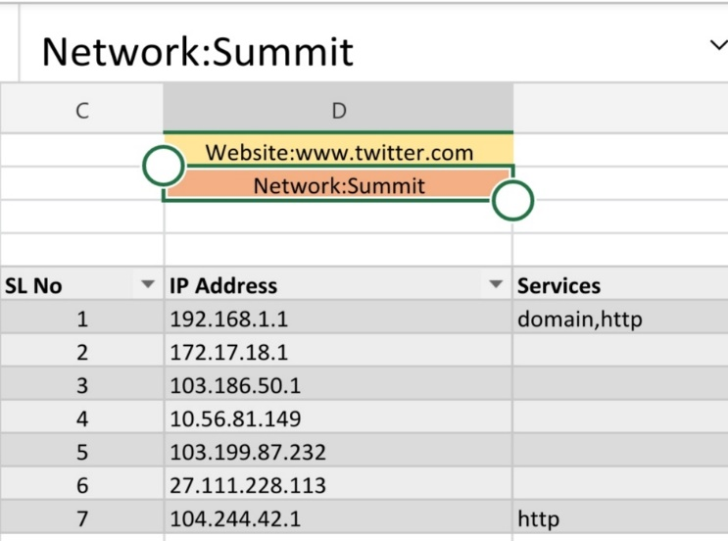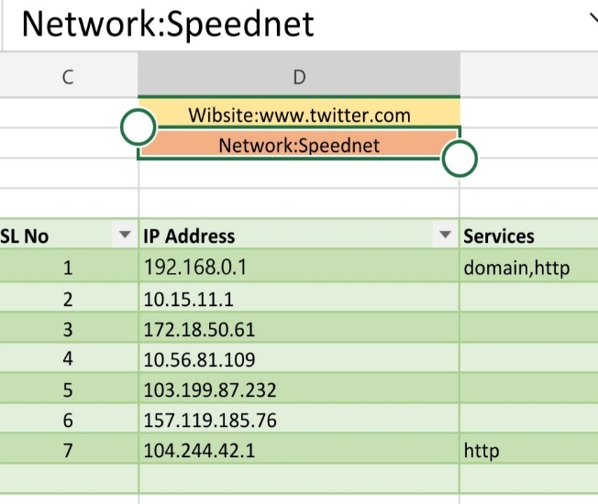

Fig 10: Service table of SpeedNet ISP Fig 11: Service table of Summit ISP

These four figures are the serial wise Ip address table. We get this information from Zen map by scanning Twitter. Four different network goes to target address by many different Ip address. Now we will create a excel tracert for visualize the simulation process.

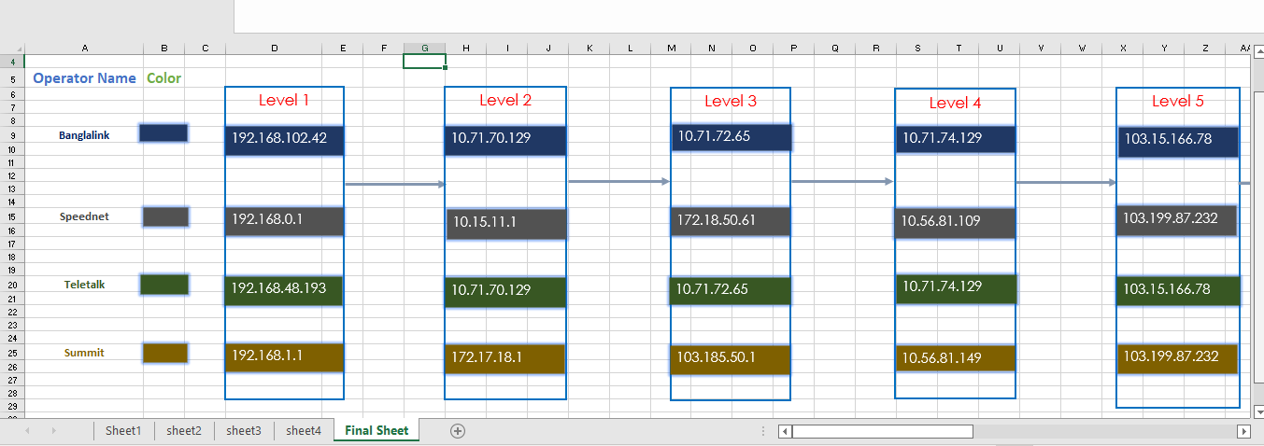

Fig 12: First-half excel sheet tracert

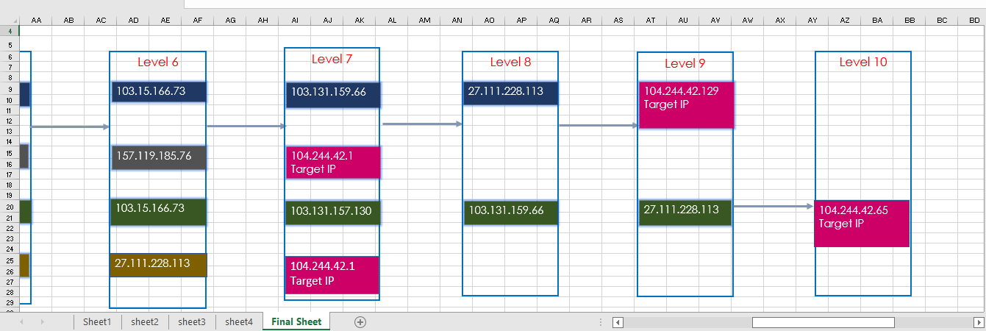

Fig 13: Last-half excel sheet tracert

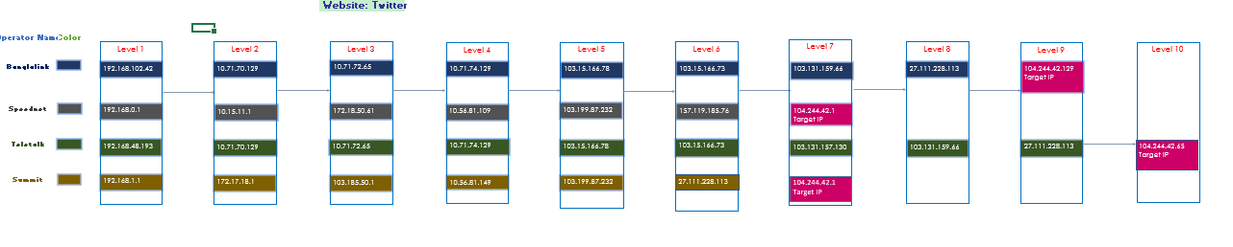

Fig 14: Full excel sheet tracert

# 5.Introduction to NS2

# Network Simulator 2 (NS2) provides substantial support for simulation of different protocols over wired and wireless networks.NS-2 can be used to implement network protocols such as TCP and UDP,traffic source behavior such as FTP, Telnet, Web, CBR, and VBR,

# router queues management mechanism such as Drop Tail, RED, and CBQ,

# routingalgorithms, and many more.

# 6.Source code of NS2

The source code of NS2 are edit and store in TCL extension file.

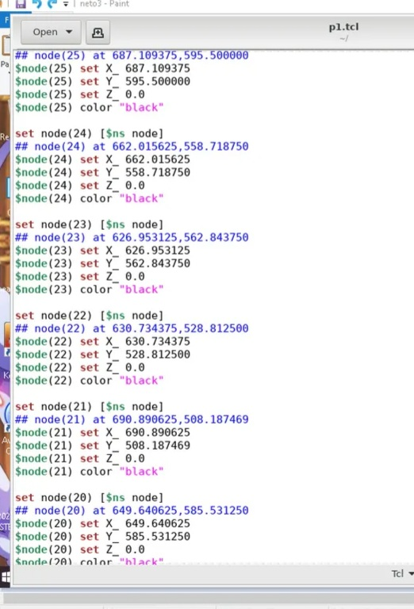

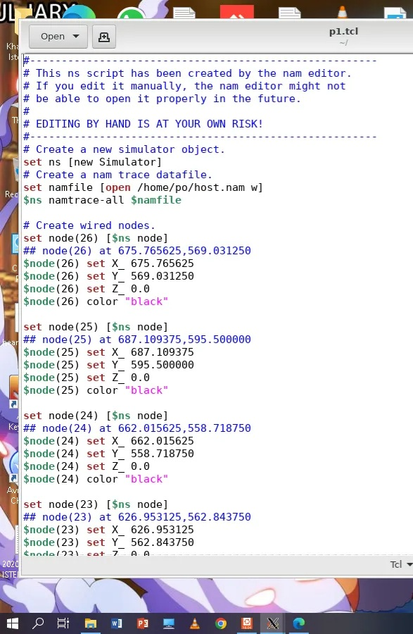

\

# 

# 

# 

# 

# 

# 

Fig 15: Source code of NS2

# 7.Output topology of NS2

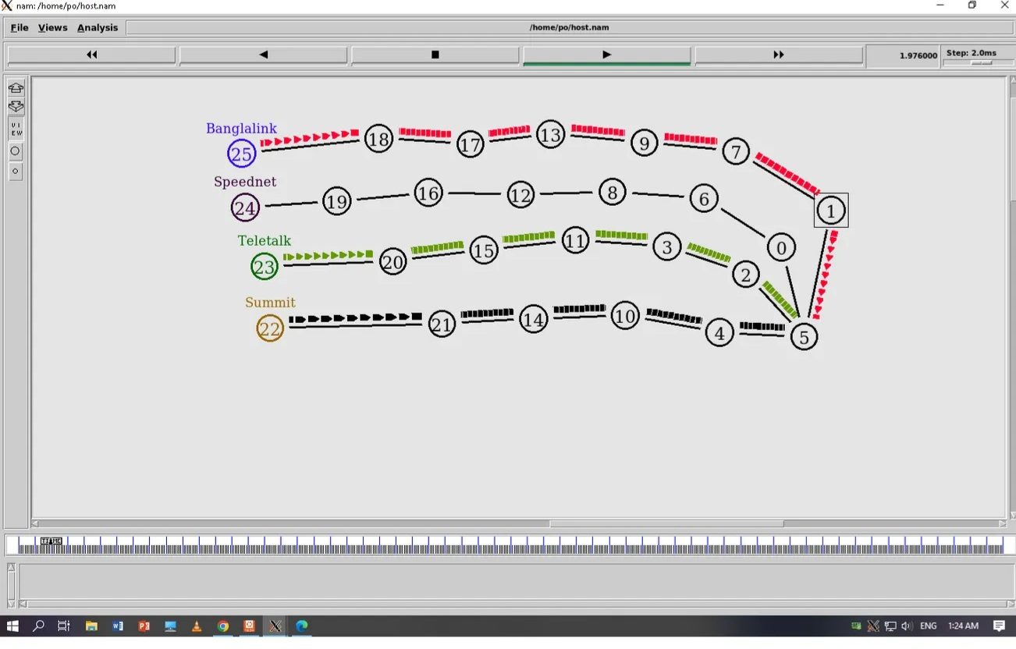

Fig 16: Final output of NS2

In this position we can see that the data packets are going to the target point

# 8.Summarization of the designed network

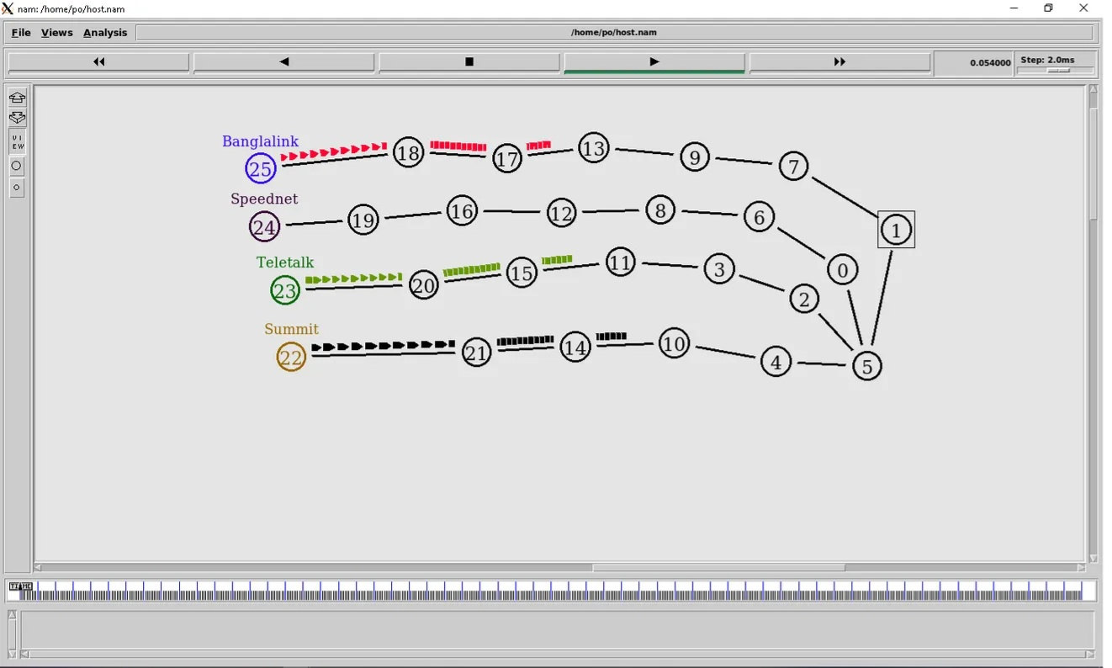

Fig 17: After Resurrection the node

We can see the packet node these is are going to the target point and the view of output.

# 

# 9.Conclusion

This lab is dedicated for students to work on practical experiments, projects and research work related to courses such as Computer Networks, Wireless Networks, Mobile Communications, Software-Defined Networking, Internet of Things, Future Networks and Cloud Computing. This Network Simulation tool allows users to create network topologies and imitate those in modern computer network. Zen map and Network Simulator 2 are powerful tools for network administrators to use in order to test and troubleshoot network configurations. Zen map provides a graphical user interface for network scanning and security auditing, while Network Simulator 2 allows users to model and simulate networks for testing purposes. Both tools are easy to use and can help administrators to quickly identify and resolve network issues. Additionally, both tools are free and open source, making them accessible to a wide range of users.

# 10.Reference

# 

https://iiitbh.ac.in/cn-lab